**Project Design Phase-II**

**Data Flow Diagram & User Stories**

|  |  |
| --- | --- |
| Date | 27 June 2025 |
| Team ID | LTVIP2025TMID29337 |
| Project Name | Health AI: Intelligent Healthcare Assistant Using IBM Granite |
| Maximum Marks | 4 Marks |

**Data Flow Diagrams:**

A Data Flow Diagram (DFD) is a traditional visual representation of the information flows within a system. A neat and clear DFD can depict the right amount of the system requirement graphically. It shows how data enters and leaves the system, what changes the information, and where data is stored.

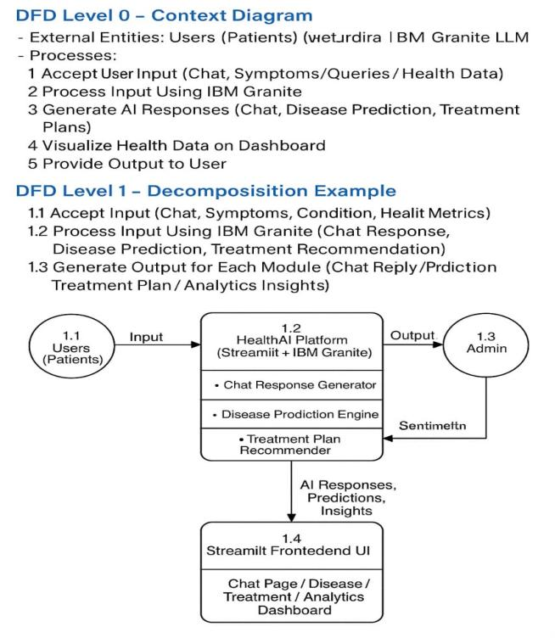

**User Stories**

Use the below template to list all the user stories for the product.

| **User Type** | **Functional Requirement (Epic)** | **User Story Number** | **User Story / Task** | **Acceptance criteria** | **Priority** | **Release** |
| --- | --- | --- | --- | --- | --- | --- |
| Patient (Web User) | Registration/Login | USN-1 | As a Patient, I can register for the application by entering my email, password, and confirming my password. | I can access my account / dashboard and chats | High | Sprint-1 |
| Patient (Web User) | Patient Chat Assistant | USN-2 | As a patient, I can ask health-related questions and receive clear, empathetic AI responses with medical facts and advice when to consult a doctor. | I get a factual, empathetic response with limitations explained and suggestions for professional consultation if needed. | Medium | Sprint-1 |
| Patient (Web User) | Disease Prediction | USN-3 | As a patient, I can input my symptoms to receive possible condition predictions with likelihoods and next steps. | I get list of predicted conditions with likelihood scores and recommended next actions. | High | Sprint-1 |
| Patient (Web User) | Treatment Plan Generator | USN-4 | As a patient, I can enter my diagnosed condition to receive personalized treatment plans including medications, lifestyle changes, and follow-up tests. | I receive a treatment plan that includes evidence-based medications, lifestyle advice, and recommended tests. | High | Sprint-2 |
| Patient (Web User) | Health Analytics Dashboard | USN-5 | As a patient, I can view my health trends and vital signs over time with AI-generated insights and recommendations. | I see graphical trends of my vitals and get insights with improvement suggestions or alerts for concerns. | High | Sprint-2 |
| Admin(Government) | Authentication | USN-6 | As an admin, I can securely log in to manage the Health AI system and access only authorized administrative pages. | I am redirected to the admin dashboard after successful login, and unauthorized access is restricted. | Medium | Sprint-2 |